**Experiment No. 05**

**AIM: To Build the pipeline of jobs using Maven /Gradle /Ant in**

**Jenkins,create a pipeline script to Test and deploy an application over the tomcat server.**

**THEORY:**

Jenkins is an open-source automation server used to implement Continuous Integration (CI) and Continuous Deployment (CD) in software development. It helps automate tasks like building, testing, and deploying code, improving efficiency and reducing human errors. **Key Concepts:**

1. **Automated Builds**: Jenkins automatically compiles code whenever changes are made, ensuring that the software is always in a buildable state.

1. **Continuous Integration**: Developers frequently commit code to a shared repository.

Jenkins automatically triggers builds and runs tests to detect issues early.

1. **Pipelines**: Jenkins workflows are defined using Pipelines in a Jenkinsfile, which can be scripted or declarative.

1. **Plugins**: Jenkins supports plugins for version control (Git), build tools (Maven, Gradle), deployment (Docker, Kubernetes), and more.

1. **Freestyle Projects vs. Pipelines**:

○ **Freestyle Projects**: Simple, GUI-based jobs for basic automation.

○ **Pipelines**: Code-defined workflows for complex CI/CD tasks.

**Example of a Simple Jenkins Pipeline (Declarative):**

pipeline { agent any stages { stage('Build') { steps { sh 'echo "Building the project"'

} } stage('Test') { steps { sh 'echo "Running tests"'

}

}

stage('Deploy') { steps { sh 'echo "Deploying the application"'

}

}

}

}

This pipeline defines three stages: **Build**, **Test**, and **Deploy**, each with its own commands.

**Output:**

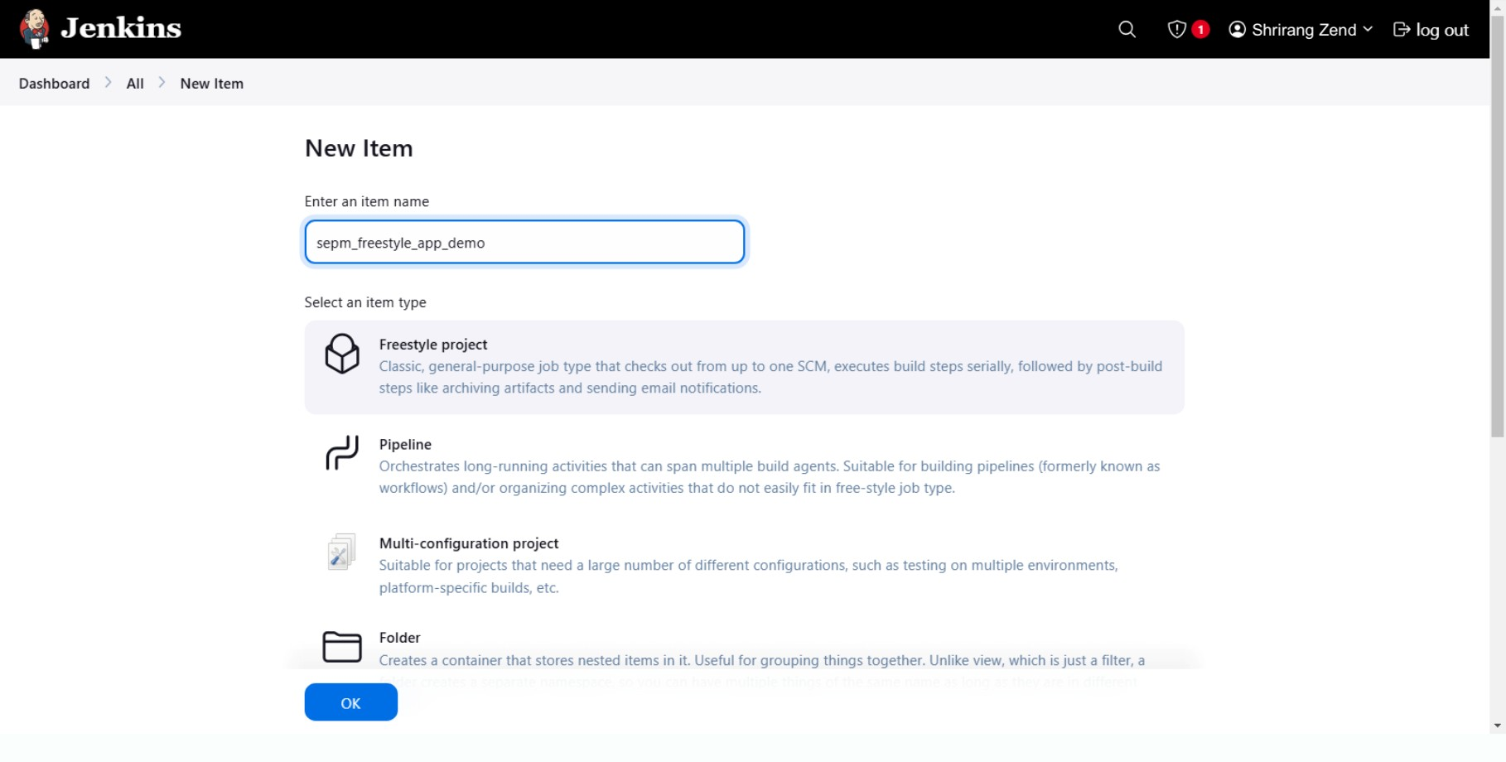

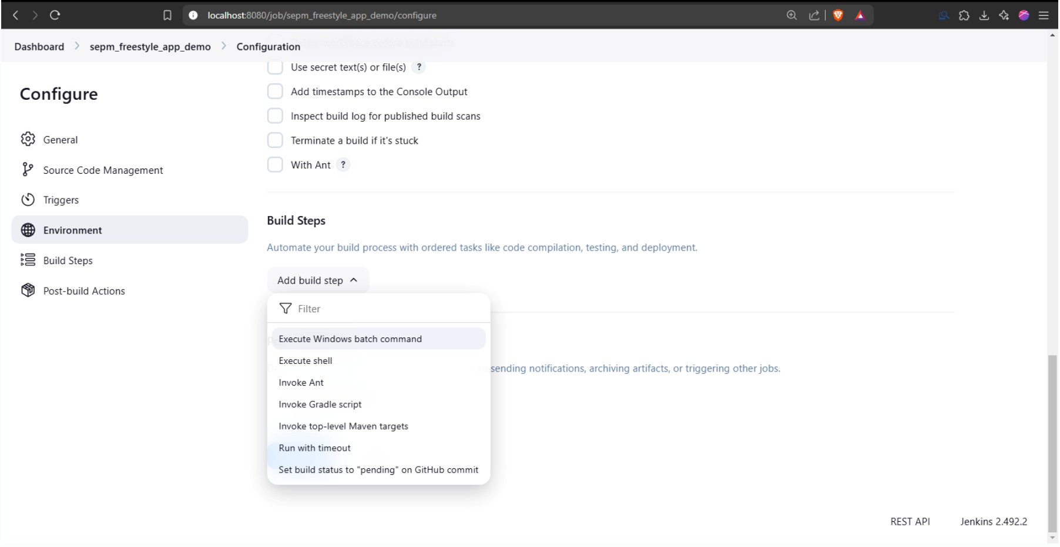

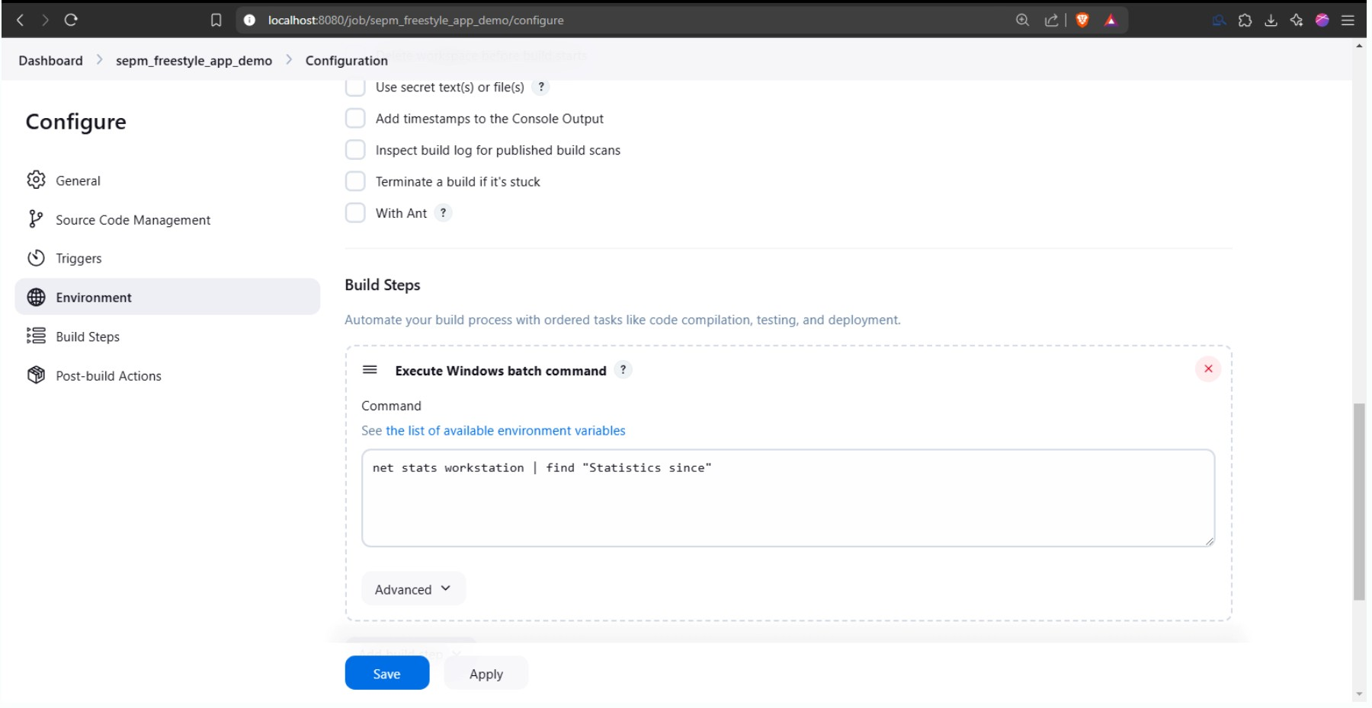

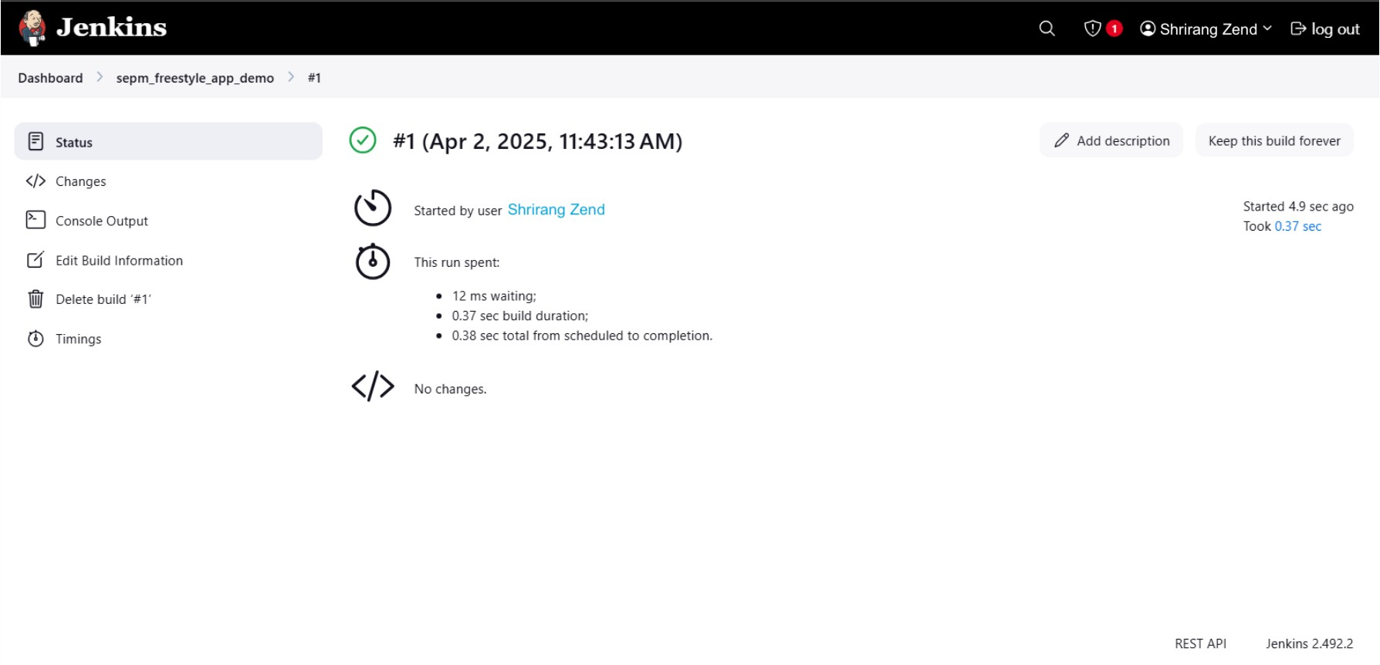

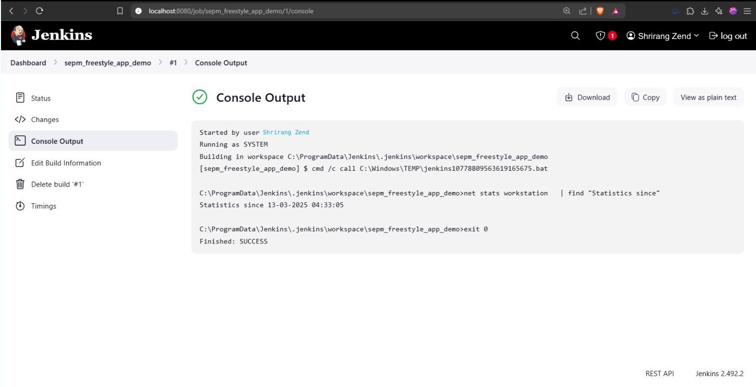

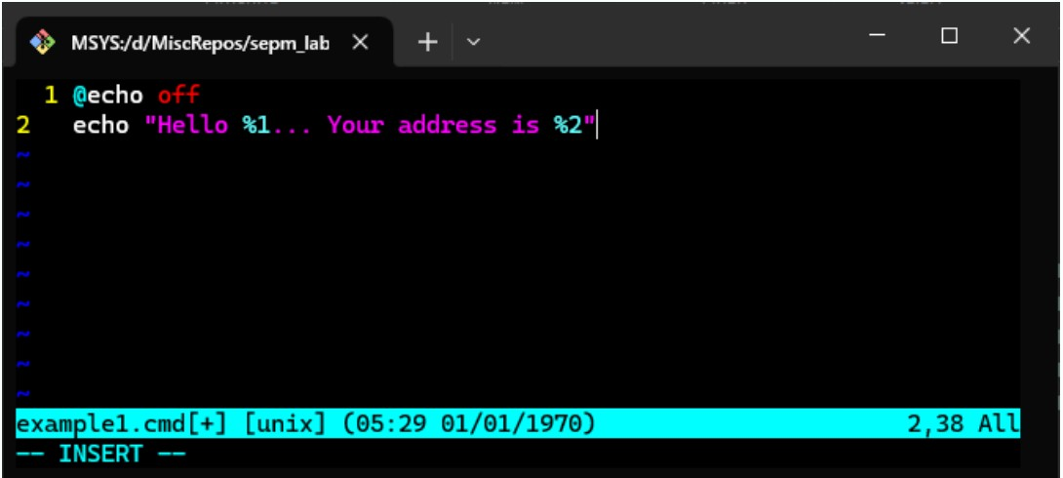

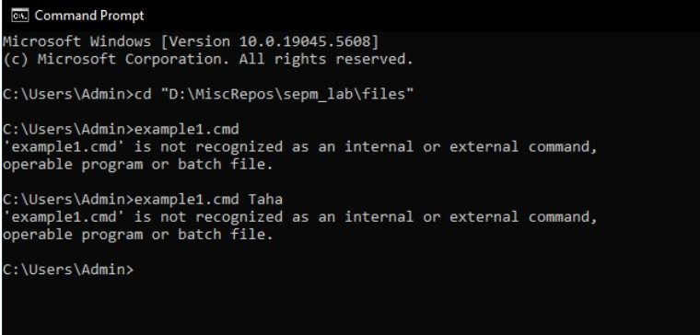

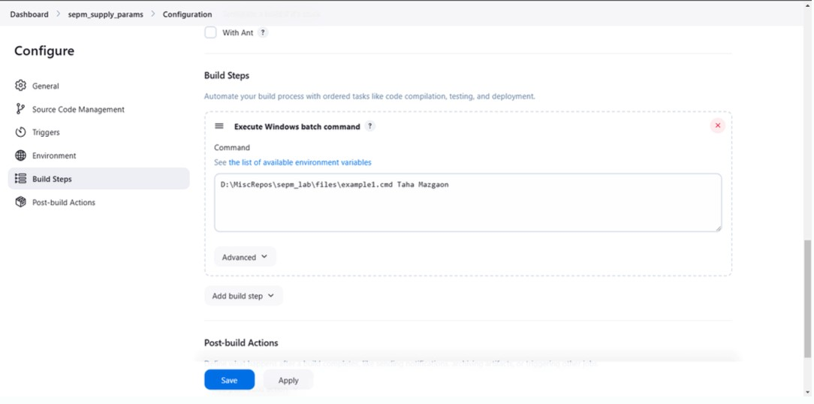

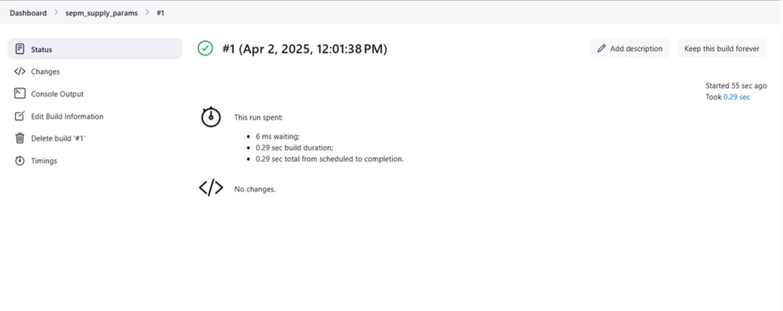

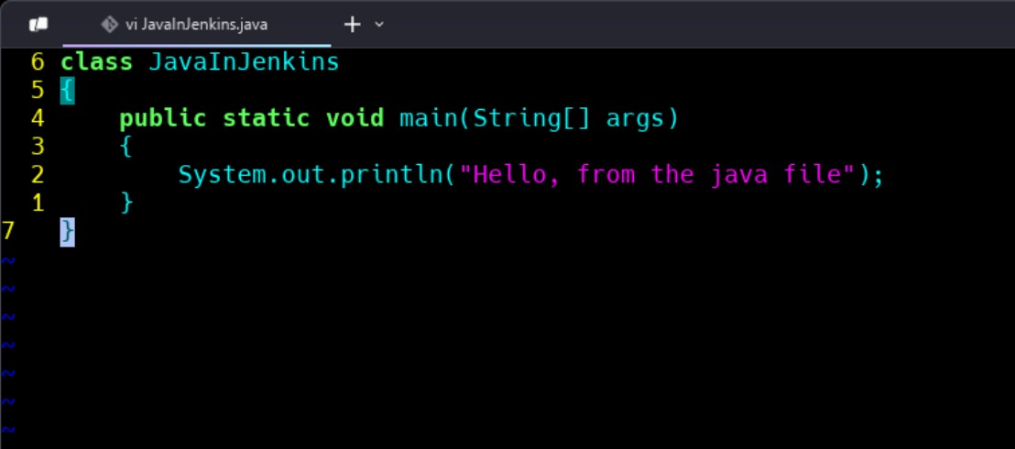

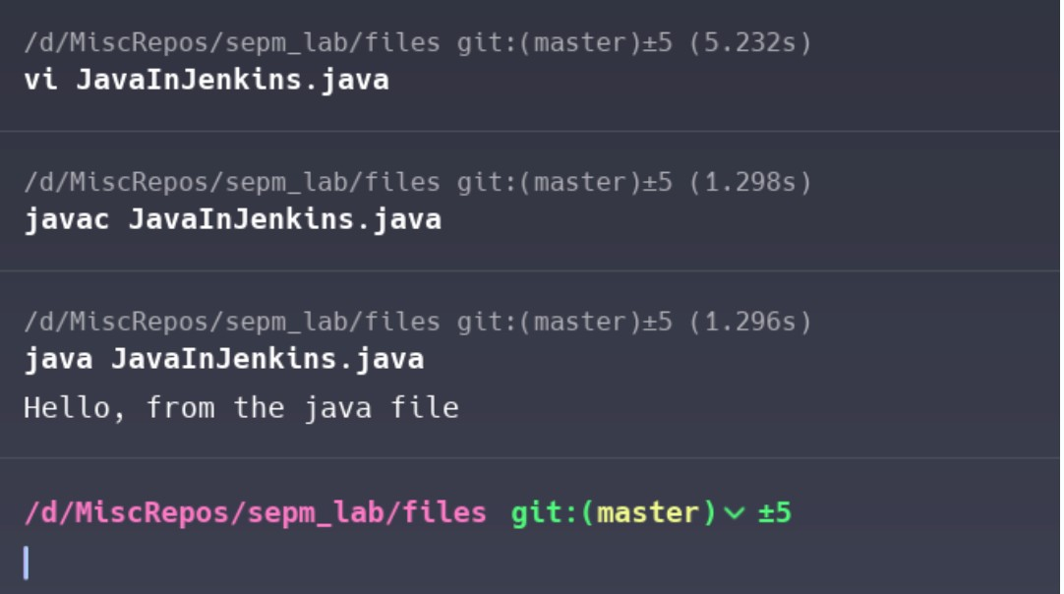

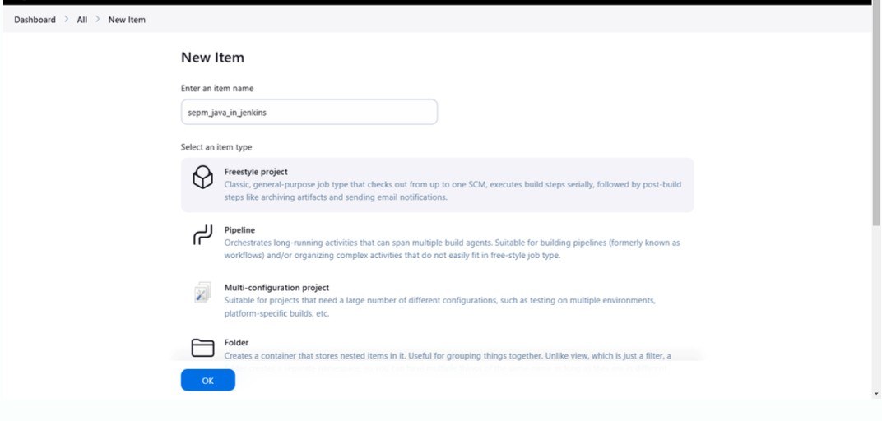

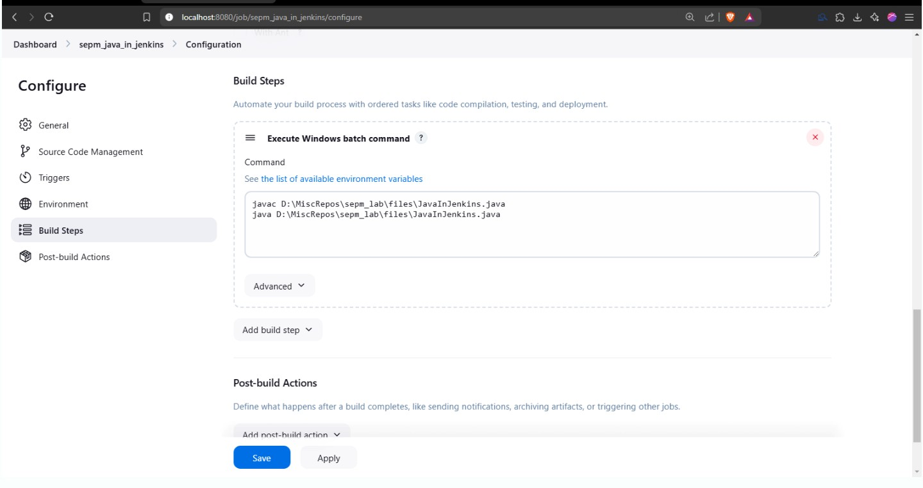

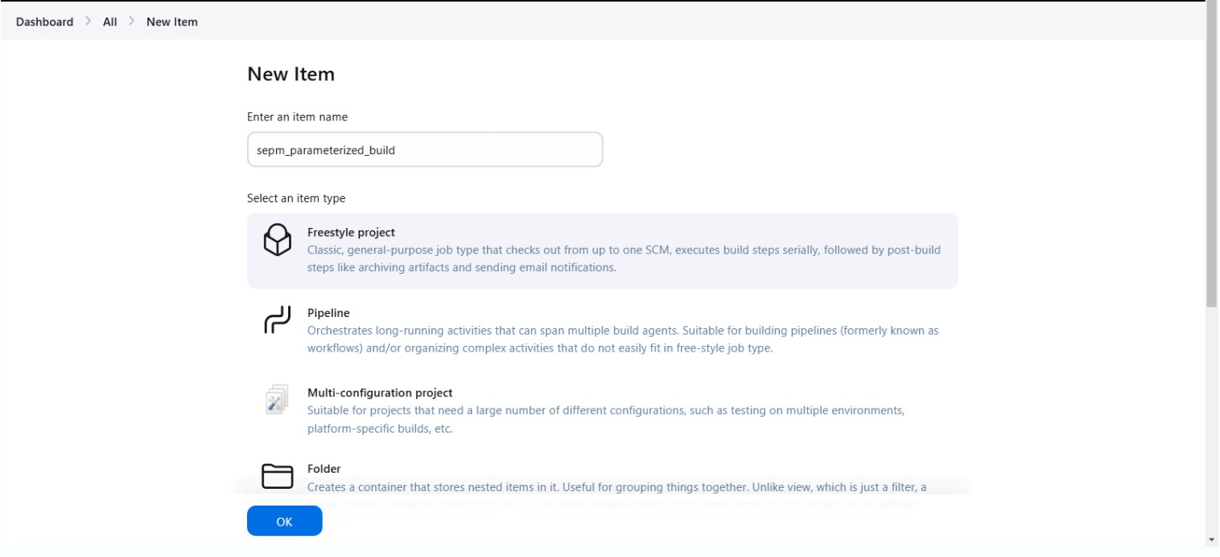

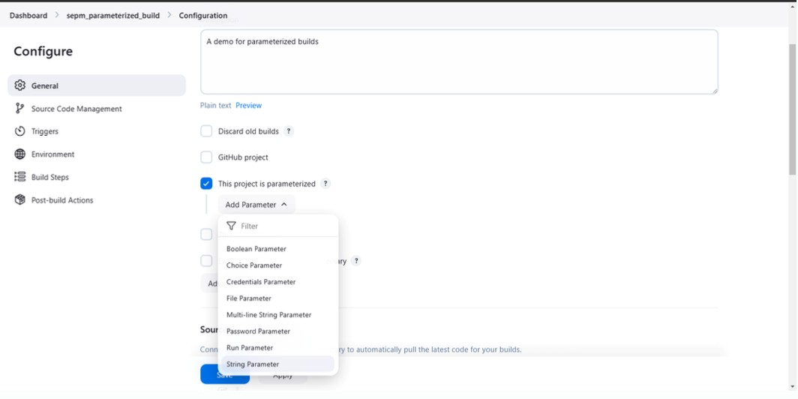

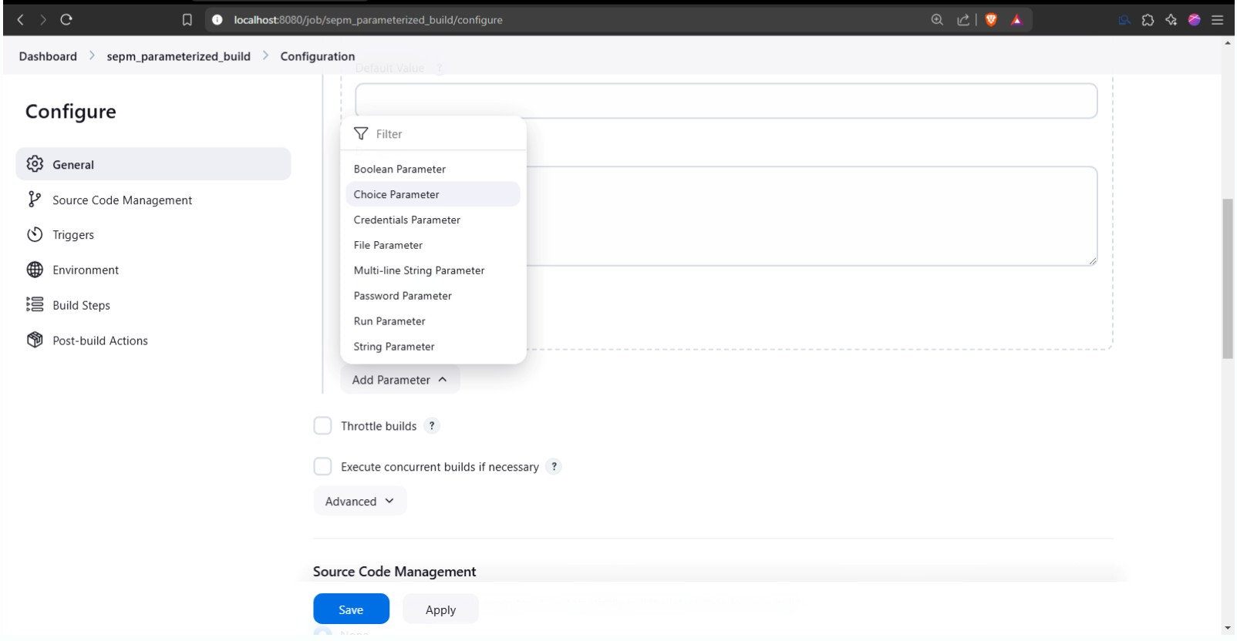

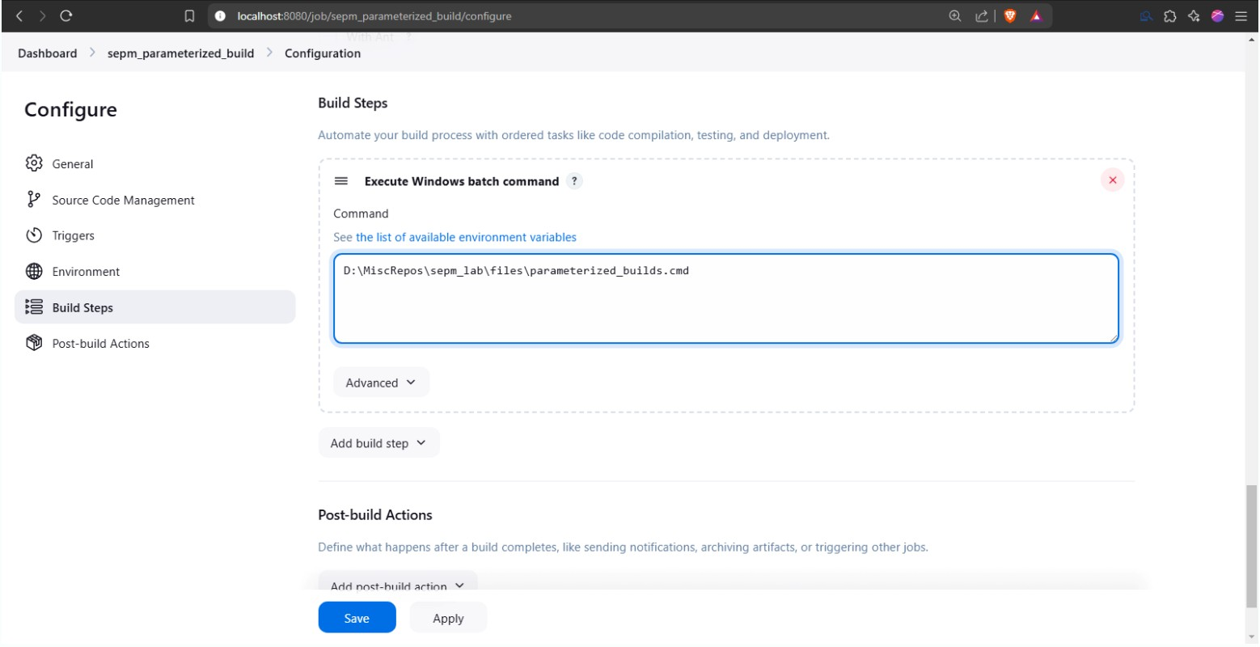

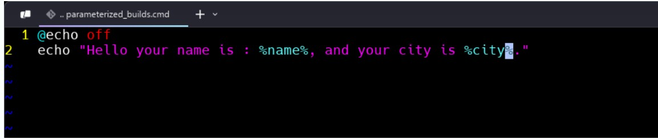

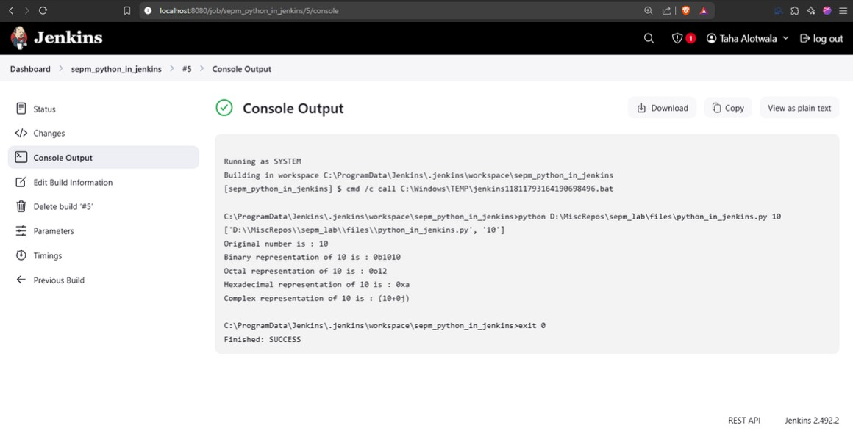

**CONCLUSION: Hence, we have successfully created a VPC Service for launching the Instances.**